**2020 Project Performance Assessment: tool documentation**

# Using this Guide

The Project Performance Assessment (PPA) tool links the numerous data sources SACOG tracks and maintains with key policy objectives of the region’s long-range transportation plan (called the Metropolitan Transportation Plan/Sustainable Communities Strategy or MTP/SCS). A cornerstone of the tool has been to support data-driven decision making while enhancing transparency in transportation planning and programming. As such, the tool is online and open for anyone to use.

This guide serves as the documentation for the 2020 update of the PPA tool. The guide first discusses the changes to the 2020 version the tool (part 1), and then provides a description of each of the 2020 PPA indicators by program (part 2). Note that information on running the PPA is included in the tool itself (including step by step instructions), not in this documentation package.

The documentation also includes three appendices, each with additional information:

* **Appendix 1- Frequently Asked Questions** gives answers to common questions raised during the tool’s beta test period. Look to this appendix for information such as how to draw more complicated projects in the tool (eg, projects with limited access points or serving a parallel facility), which project type to use for different categories of investments (eg, off-street bike paths) or how to add user inputs (eg, pavement condition, volumes) on a facility with significant variation along its extent.
* The team added **Appendix 2- Guide to PPA Map Data Layers** in response to beta users who wanted more detail on how the data layers represented in step 1 of the tool relate to the tool’s performance indicators output table. Users can reference this appendix table while exploring the tool’s visualized data layers as a summary version to the information included in part 2 of the documentation.
* Finally, **Appendix 3- Supplemental Indicator Methodology** gives a more detailed and technical description of several of the more complex data sources and indicators, such as conflating speed data to project lines or calculating project-level accessibility. Users who are interested in the methodological approach for these indicators should refer to this final appendix.

## PPA Developer Guide

If you are interested in creating a custom version of the PPA tool to calculate metrics not included in the current tool, or to calculate metrics for areas outside of the SACOG region, please refer to the PPA Developer Guide. The Developer Guide describes the necessary scripts, input files, and setup processes needed to create and publish the PPA tool.

# Background

In response to board direction and input as well as federal and state emphasis on performance-based transportation planning and programming, SACOG staff has continued to enhance tools and methods to analyze transportation investments at the project-level.

The Project Performance Assessment (PPA) tool is a major component of SACOG’s practice to provide quantitative indicators and other information that help inform regional decision making. The tool draws on multiple data sources to give a consistent and transparent baseline to measure performance for different transportation projects across the region, is online and open for any to use, and has been used as part of the 2018 and 2019 funding rounds to both streamline the data component for applicants as well as improve transparency in performance-based programming. See the [2018 PPA documentation](https://www.sacog.org/sites/main/files/file-attachments/ppa_documentation_regional_program_1.pdf?1528147505) for a description of the initial version of the tool.

Since its initial rollout in the 2018 funding round SACOG staff conducted a self-assessment of the first iteration of the PPA tool. This review also incorporated valuable comments provided by project sponsors and other tool users. Based on this input SACOG made numerous updates to the PPA and has released a new 2020 version of the tool. SACOG held an open beta period on the updated tool in early 2020 as an opportunity for additional comments and suggestions. SACOG staff thanks all those that participated in the beta testing for their valuable and constructive feedback.

This documentation describes using the tool within SACOG’s core competitive funding programs. Staff hopes stakeholders continue to find value in the tool outside of the regional funding round.

# Part 1. Major changes to 2020 PPA tool

The largest change for a project sponsor is that the 2020 PPA tool now reports different data indicators based on project type and funding program, as reported in the tables below. The Regional Program allows the user to choose from three possible project type categories: 1) freeways, 2) road maintenance and complete streets (for Maintenance & Modernization category), or 3) transit or road expansion (for Transformative category). Note that transit state of good repair projects, such as bus or light rail vehicle replacements, do not use the PPA tool, as there is not a geographic component to these projects. Transit state of good repair projects instead use the separate Transit Asset Management. Sponsors using PPA for the Community Design program will use a separate version of the tool with its own performance outcomes. This new functionality responds to feedback from users of the 2018 tool to better account for different project types, in particular, freeway projects which have vastly different travel sheds compared to local roads.

2020 Project Performance Assessment: Indicators for 2020 Regional Program by Project Type

|  |  |  |  |
| --- | --- | --- | --- |
|  | **Freeways** | **Maintenance and Complete Streets (Maintenance & Modernization category)** | **Transit and Road Expansion (Transformative category)** |
| **Performance Outcome** | **Indicators by Project type** | | |
| **Reduce VMT/capita** | -transit trips -avg vehicle occupancy on project | -jobs + DUs -land use diversity -neighborhood services accessibility | -change in jobs + DUs -change in land use diversity -neighborhood services accessibility |
| **Reduce congested VMT/ capita** | - congestion severity - travel time reliability | - congestion severity - travel time reliability | - congestion severity - travel time reliability -growth in project corridor |
| **Increase multi-modal travel** | -transit person-trips on segment | -street connectivity -bike network connection -transit activity -residential mode split | -street connectivity -bike network connection -transit activity -residential mode split |
| **Econ prosperity (jobs)** | -job access | -job access | -job access -job growth |
| **Econ prosperity (schools)** | -school access -school enrollment | -school access -school enrollment | -school access -school enrollment |
| **Econ prosperity (agriculture)** | -acres of ag land near project | -acres of ag land near project | -acres of ag land near project |
| **Improve freight movement** | -STAA truck route status -truck mode share | - STAA truck route status -industrial jobs share | - STAA truck route status -industrial jobs share -industrial job growth |
| **Safety** | -total collisions -collision rate | -total collisions -collision rate -bike/ped collision & rate | -total collisions -collision rate -bike/ped collision & rate |
| **Maintain State of Good Repair** | -not applicable to PPA; uses SHOPP program | -PCI -volumes -Complete Street index | -PCI -volumes |
| **Socioeconomic Equity** | -Replica post-processing indicators | -EJ population -EJ percent -EJ accessibility | -EJ population -EJ percent -EJ accessibility |

2020 Project Performance Assessment: Indicators for 2020 Community Design program

|  |  |
| --- | --- |
| **Blueprint Principle** | **Indicator** |
| **Transportation Choice** | Transportation mode split for residents within half mile of corridor, 2016 and 2040 |
| **Compact Development** | Combined jobs and housing units within half mile of project location, 2016 and 2040 |
| **Mixed-Use Development** | Land Use Diversity Index within 1 mile of project location, 2016 and 2040 |
| **Housing Choice** | Housing type mix within 1 mile of project location, 2016 and 2040 |
| **Use Existing Assets** | Travel time accessibility to neighborhood amenities by transportation mode, 2016 only  Infill/greenfield project location |
| **Preserve Natural Resources** | Combined acres of forest, agricultural land and park/open space within half mile of project location, 2016 and 2040 |
| **Quality Design** | No quantitative indicators |

Summary of the different tool applications

Sponsors using the PPA tool as part of SACOG’s Regional Program select one of the three project types (freeway, arterial maintenance/complete streets, arterial or transit service expansion). These three project types use different indicators to measure the program’s performance outcomes. Projects applying to Community Design use the separate Community Design version of the tool regardless of project type.

* **Freeway** project type (first of three project types in Regional Program). Any project primarily on a limited access freeway would use this category. This includes general purpose lanes, auxiliary lanes, HOV/managed lanes, on/off ramps, interchanges, etc. As explained in the description of the indicators below, the indicators in this category look much more at the facility itself, and less at the surrounding land uses.
* **State of Good Repair/Maintenance** project type (second of three project types in Regional Program, used for projects applying in the Maintenance & Modernization program category), for projects that do not add capacity for any motorized modes. Projects in this second category include road rehabilitation projects, projects adding bike lanes and other active transportation amenities to existing facilities, or other complete streets or operation projects. As the project serves to maintain and enhance existing communities and networks, most of the indicators in this category draw on data for existing conditions. However, some of its indicators do include future data as a reference point for projects proposed for existing corridors that are planned for redevelopment/revitalization. As discussed above, the PPA does not assess transit vehicle replacement projects.
* **Transit or arterial expansion** project type (third of three project types in Regional Program, used for projects applying in the Transformative program category). This category includes any project that adds roadway capacity (i.e., adding an additional lane to a road, or building a new facility) or any new transit service (both bus and rail), or building a new separated bike/ped trail/path. As these projects add to the regional transportation network, the PPA brings in data both on existing conditions as well as projected change in the project corridor. Note that a maintenance project request above $5 million needs to apply through the Transformative program category, so would use this third project type definition in the PPA.
* Sponsors with questions about which project category to use can refer to the PPA FAQ section.
* **Community Design**. Sponsors applying to the Community Design program use this category regardless of project type. Community Design has a separate set of performance outcomes and indicators.

Other changes to the 2020 update to PPA tool:

* Augmented observed data, including congestion, reliability, safety, and land use
* Improvements to project buffer approach and indicators based on project type (freeway, expansion and maintenance/complete streets)
* Expanded number of place types, allowing for fuller comparisons to projects in similar contexts (e.g., rural main street projects compared to other rural main street projects, suburban corridors compared to other suburban corridors, etc)
* Improvements to the online tool stability, continuing the ability of anyone with an internet browser to run the tool and see the data results
* Limited number of indicators by performance outcome (reducing 5 indicators per outcome in original version to 2 or 3 in 2020 version). Part 2 of this document describes each of the indicators in the 2020 version
* Expanded description in FAQ document of how to use the tool for regionally-serving projects that relieve conditions on parallel facilities
* Step-by-step instructions on running the PPA in the browser-based tool itself

# Part 2. Description of 2020 PPA Indicators

This section describes the performance outcomes and data indicators in the 2020 PPA tool.

The Regional Program has seven performance outcomes measured in the tool:

* Reduce regional VMT per capita
* Reduce regional congested VMT per capita
* Increase Multimodal Travel/Alternative Travel/Choice of Transportation options
* Provide long-term economic benefit within the region, recognizing the importance of sustaining urban, suburban, and rural economies
* Improve Goods Movement, including Farm-To-Market travel, in and through the region
* Significantly improve safety and security
* Demonstrate ‘State of Good Repair’ benefits that improve the efficiency of the existing transportation system
* The program also includes equity indicators as a cross-cutting measure.

The Community Design program has a separate set of performance outcomes measured in the PPA, based on the blueprint principles:

* Transportation choice
* Compact development
* Mixed-use development
* Housing choice
* Use existing assets
* Preserve natural resources
* Quality design

After the project sponsor inputs the project information into the online interface (see step by step guide in tool itself), the PPA tool will calculate data indicators for each of the above outcomes, based on project category. For the funding round the project sponsor will only select a subset of the performance outcomes to be evaluated on. SACOG will only bring forward the data indicators in the sponsor-selected performance outcomes.

Definitions

|  |
| --- |
| *Performance Outcome:* one of the seven outcomes used in the funding round to support MTP/SCS implementation |
| *Indicator*: specific data to evaluate performance on the given outcome. Each performance outcome has two to three data indicators |

## How to interpret the indicators

Context, not causality  
The PPA uses a variety of data sources to produce data indicators across each of the associated performance outcomes. The tool, however, is not a benefit/cost analysis or other methodological approach that conducts separate simulations to model or estimate the difference between a scenario with the project built to one with the project not constructed.

Instead, the PPA tool aims to strike a balance of three goals: coverage (applicable to a wider variety or projects), user access (a tool that runs in a reasonable amount of time and without specialized or proprietary licensing) and reportability (a transparent tool that produces specific performance indicators on individual transportation projects). As such, it does not run a separate travel demand model for each project (for context, SACOG’s travel demand model takes more than twenty hours to run a single time and requires both specialized software and a trained analyst to use. In contrast, the PPA tool runs in a few minutes, and is open to anyone with an internet connection).

In contrast to a benefit/cost analysis, the indicators produced in the PPA are not causal. Many PPA indicators give information about existing conditions without the project built. While each indicator is interpreted differently (see below for each indicator), these existing condition indicators help illustrate if there is a performance need within the outcome. The sponsor still needs to document in the narrative portion of the application how the project’s design elements respond to the identified performance need.

Several PPA indicators also include estimates about the project corridor for the year 2040. Importantly, these future year estimates are *not* a project/no project comparison. Rather, they depict the vision for the corridor based on SACOG’s MTP/SCS. Sponsors will document in the narrative portion of the application how the project design aligns with and can help realize the MTP/SCS vision. In other words, users and evaluators should not interpret the 2040 indicators as a causal result of the project.

Place type comparisons  
The PPA tool provides regional and place/community type averages on each indicator. The place/community type average is an important part of the evaluation framework, where projects are compared relative to size and community type. The 2020 version has expanded the number of place/community types to better reflect the diversity of the region. The place/community type categories included in the 2020 PPA tool are:

* Agriculture and open space
* Rural residential
* Rural and Small Town Main Street
* Small Town Established Communities
* Developing Communities
* Established Communities
* Arterials and Suburban Corridors
* Urban Core

## Regional Program Performance Outcomes

Performance Outcome #1. Regional Reduction in VMT Per Capita A vehicle mile traveled, or VMT, is one vehicle traveling on a roadway for one mile. Each vehicle traveling on a roadway within the Sacramento region generates one VMT for each mile it travels, regardless of how many people are traveling in the vehicle.

#### Freeway VMT Indicators

Indicator: Daily Transit Person-Trips  
Facility or Buffer: Facility  
Data Year: 2016 and 2040  
Description: This indicator estimates daily transit trips on the facility, both for current conditions (2016) and future conditions (2040).

Indicator: Average Weekday Vehicle Occupancy  
Facility or Buffer: Facility  
Data Year: 2016 and 2040  
Description: This measure estimates the average number of travelers per passenger vehicle on a typical weekday, using the SACSIM travel model. The indicator reports for current conditions (2016) as well as future conditions in the horizon year of the MTP/SCS (2040) with the project built. Freeway elements such as HOV lanes can increase the number of passengers per vehicle and thus reduce VMT/capita.

#### Maintenance/Complete Streets VMT Indicators

Indicator: Combined jobs and dwelling units within 0.5mi of project  
Facility or Buffer: Buffer  
Data Year: 2016 and 2040  
Description: This indicator measures current total combined jobs and dwelling units within 0.5mi of the project, compared to those in a similar place type. Projects with more trip generators (houses and jobs) nearby can support lower VMT/capita given the concentration of activities and destinations. As the projects within the maintenance/ complete streets category focus on serving existing communities, indicators in this outcome focus primarily on current conditions.

Indicator: Land Use Diversity index (0 to 1, with a higher score more reflective of diverse land uses)  
Facility or Buffer: Buffer  
Data Year: 2016 and 2040  
Description: The land use diversity index measures an area’s ratio of households compared to neighborhood activities (K-12 enrollment, park acreage, and employment in the retail, service and food sectors). A score of 1 indicates an ‘ideal’ ratio of households to amenities that people use on a daily basis like shopping, restaurants, schools, etc. Areas with a mix of land uses increase the likelihood that vehicle trips are shorter per capita and can also be served by active transportation modes. Note the land use diversity uses a buffer of 1 mile, instead of the shorter 0.5 mile buffer used in other buffer metrics. The supplemental indicator methodology appendix gives a more technical description of this indicator for those interested.

Indicator: Neighborhood Services Accessibility (points of interest)  
Facility or Buffer: Facility  
Data Year: 2019  
Description: The point of interest accessibility indicator estimates the number of neighborhood services a user can access on the facility, by different travel modes. The metric defines these “points of interest” as parks, K-12 schools, higher education facilities, libraries, hospitals, other medical facilities, pharmacies, grocery stores, retail clothing stores and banks. The supplemental indicator methodology appendix gives a more technical explanation of this indicator for those interested.

#### Road/Transit Expansion VMT Indicators

Indicator: Combined jobs and dwelling units within 0.5mi of project   
Facility or Buffer: Buffer  
Data Year: 2016 and 2040  
Description: This indicator measures current total combined jobs and dwelling units within 0.5mi of the project, as well as the projected totals in the horizon year of the current MTP/SCS (2040), helping to show if the project is serving an area with forecasted growth in jobs and housing.

Indicator: Land Use Diversity index (0 to 1, with a higher score more reflective of diverse land uses)  
Facility or Buffer: Buffer  
Data Year: 2016 and 2040  
Description: The land use diversity index measures an area’s ratio of households compared to neighborhood activities (K-12 enrollment, park acreage, and employment in the retail, service and food sectors) for both current and forecast conditions. A score of 1 indicates an ‘ideal’ ratio of households to amenities that people use on a daily basis like shopping, restaurants, schools, etc. Areas with a mix of land uses increase the likelihood that vehicle trips are shorter per capita and can also be served by active transportation modes. The land use diversity uses a buffer of 1 mile, instead of the shorter 0.5 mile buffer used in other metrics. The supplemental indicator methodology appendix gives a more technical explanation of this indicator.

Indicator: Neighborhood Services Accessibility  
Facility or Buffer: Facility  
Data Year: 2019   
Description: The point of interest accessibility estimates the number of neighborhood services a user can access on the facility, by different travel modes. The metric defines these “points of interest” as parks, K-12 schools, higher education facilities, libraries, hospitals, other medical facilities, pharmacies, grocery stores, retail clothing stores and banks. The supplemental indicator methodology appendix gives a more technical explanation of how the PPA tool calculates project-level accessibility.

### Performance Outcome #2. Regional Reduction in Congested VMT Per Capita

#### Freeway Congestion Indicators

Indicator: Traffic congestion ratio (lower the number, higher the congestion issue)  
Facility or Buffer: Facility  
Data Year: 2018  
Description: This indicator uses observed speed data to compare travel speed on the facility during its slowest four-hour period to its free-flow speed. Often this slowest period overlaps with peak period travel, but not all facilities have their slowest travel during peak period. (The tool will use the slowest four-hour segment regardless of it is in the peak period or not). The tool defines free-flow speed as the 85th percentile speed between the hours of 8pm and 6am, which is meant to reflect conditions where there is no traffic congestion. The lower the ratio of congested speed to free-flow speed, the more severe the congestion during the slowest time of day. For example, if a facility has a free-flow speed of 60mph, and its slowest speed during the day is 50mph, its congestion score would be .83 (50/60). A facility that has a free-flow speed of 60mph and its slowest speed is 30mph would have a congestion score of 0.5, and would have a higher congestion severity in the PPA tool. The supplemental indicator methodology appendix gives more information on how the PPA tool uses observed speed data.

Indicator: Travel time reliability (higher the ratio, the less reliable the facility)  
Facility or Buffer: Facility  
Data Year: 2018  
Description: This indicator uses observed speed data to compare the 80th percentile travel time on the facility to the 50th percentile (or median) travel time. For example, if half of all trips take 10 minutes or fewer on the facility, and 80 percent of all trips take 15 minutes or fewer, the travel time reliability indicator is 1.5 (15/10). The higher the ratio, the less reliable the facility. The percentiles used in this ratio come from MAP-21 performance rules. MAP-21 considers a corridor “unreliable” if its ratio is more than 1.5. The supplemental indicator methodology appendix gives more information on how the PPA tool uses observed speed data.

#### Maintenance/Complete Streets Congestion Indicators

Indicator: Traffic congestion ratio (lower the number, higher the congestion issue)  
Facility or Buffer: Facility  
Data Year: 2018  
Description: This is the same indicator as that used for freeway projects (see description above). The lower the congestion ratio, the more severe the speed degradation.

Indicator: Travel time reliability (higher the ratio, the less reliable the facility)  
Facility or Buffer: Facility  
Data Year: 2018  
Description: This is the same indicator as that used for freeway projects (see description above). The higher the reliability ratio, the less reliable the facility given the observed data.

#### Expansion Congestion Indicators

Indicator: Traffic congestion ratio (lower the number, higher the congestion issue)  
Facility or Buffer: Facility  
Data Year: 2018  
Description: This is the same indicator as that used for freeway projects (see description above). The lower the congestion ratio, the more severe the speed degradation.

Indicator: Travel time reliability (higher the ratio, the less reliable the facility)  
Facility or Buffer: Facility  
Data Year: 2018  
Description: This is the same indicator as that used for freeway projects (see description above). The higher the reliability ratio, the less reliable the facility given the observed data.

Indicator: Growth in jobs and dwelling units  
Facility or Buffer: Buffer  
Data Year: 2040 compared to 2016  
Description: The first two congestion metrics used across project type (above) speak to existing congestion and reliability needs. For projects applying under the expansion category the PPA tool also brings forward data about the projected growth in the corridor, i.e., future contributing factors of congestion based on the growth in the corridor within the MTP/SCS.

### Performance Outcome #3. Increase in Multimodal Travel/Alternative Travel/Choice of Transportation Options

#### Freeway Multi-modal Indicators

Indicator: Daily Transit Person-Trips  
Facility or Buffer: Facility  
Data Year: 2016 and 2040  
Description: This indicator estimates daily transit trips on the facility, both for current conditions (2016) and future conditions (2040). Outcome #1, Reduce VMT per Capita, also uses this same indicator for freeway projects.

#### Maintenance/Complete Streets Multi-modal indicators

Indicator: Street Connectivity  
Facility or Buffer: Buffer  
Data Year: 2016   
Description: This indicator reports the number of 3 and 4-way intersections per acre of the project travel shed in comparison to the community and regional average. The indicator’s source is SACOG’s all-street centerline file, updated each cycle of the MTP/SCS.

Indicator: Bike path/lane coverage  
Facility or Buffer: Buffer  
Data Year: 2017   
Description: This indicator reports the percent of existing network centerline miles in the project buffer shed that are either off-street bike paths or streets with bike lanes. This quantitative metric, combined with the report’s mapping of existing active transportation infrastructure, helps shed light on the bicycle network effect/gap closure potential of the project.

Indicator: Transit activity  
Facility or Buffer: Buffer  
Data Year: 2016   
Description: This indicator reports weekday transit ‘stop activity’ per acre of the project buffer. In this definition, a transit stop is not simply a stop location, but also how frequently transit serves the location. For example, an area with five transit stops with frequencies of 30 minutes each has a higher transit activity indicator than a same-sized area with five transit stops with frequencies of an hour. Note that while the indicator measures existing transit activity, it does not give information on how many individuals use this service.

Indicator: Residential mode split  
Facility or Buffer: Buffer  
Data Year: 2016 and 2040  
Description: The output’s chart shows the share of trips made by residents living within 0.5mi of the project location using each of several common modes (bike, walk, drive alone, carpool, and transit). As described earlier , the 2040 mode split is *not* an estimate of the mode shifting effects of the project. Rather it gives a sense of how well a proposed project aligns with the expected future travel modes based on the 2020 MTP’s vision for the project area. In other words, users and evaluators should not interpret the 2040 mode share as a causal result of the project.

#### Expansion Projects Multi-modal Indicators

Indicator: Street Connectivity  
Facility or Buffer: Buffer  
Data Year: 2016   
Description: This indicator reports the number of 3 and 4-way intersections per acre of the project travel shed. It also gives a comparison to the community and regional average.

Indicator: Bike path/lane coverage  
Facility or Buffer: Buffer  
Data Year: 2016   
Description: This indicator reports the percent of existing network centerline miles in the project buffer shed that are either off-street bike paths or streets with bike lanes. This quantitative metric, combined with the report’s mapping of existing active transportation infrastructure, helps shed light on the network effect/gap closure potential of the project.

Indicator: Transit activity  
Facility or Buffer: Buffer  
Data Year: 2016   
Description: This indicator reports weekday transit ‘stop activity’ per acre of the project buffer. In this definition, a transit stop is not simply a stop location, but also how frequently transit serves the location. For example, an area with five transit stops with frequencies of 30 minutes each has a higher transit activity indicator than a same-sized area with five transit stops with frequencies of an hour. Note that while the indicator measures existing transit activity, it does not give information on how many individuals uses this service.

Indicator: Residential mode split  
Facility or Buffer: Buffer  
Data Year: 2016 and 2040  
Description: The output’s chart shows the share of trips made by residents living within 0.5mi of the project location using each of several common modes (bike, walk, drive alone, carpool, and transit). As described earlier , the 2040 mode split is *not* an estimate of the mode shifting effects of the project. Rather it gives a sense of how well a proposed project aligns with the expected future travel modes based on the 2020 MTP’s vision for the project area. In other words, users and evaluators should not interpret the 2040 mode share as a causal result of the project.

**Performance Outcome #4. Provide Long-Term Economic Benefit within the Region, Recognizing the Importance of Sustaining Urban, Suburban and Rural Economies**Outcome #4 has three sub-outcomes: job accessibility, school accessibility, and agricultural economy. Project sponsors can select one of these three to speak to how the project supports the themes of the MTP/SCS and Prosperity Strategy.   
  
Job Accessibility Indicators

##### Freeway

Indicator: Jobs accessible within 30-minute car trip  
Facility or Buffer: Facility  
Data Year: 2019  
Description: This measure calculates the average number of jobs reached in within 30 minutes using the facility. Projects that improve accessibility to more jobs are more supportive of the performance outcome. The supplemental indicator methodology appendix gives more information on how the PPA tool calculates project-level accessibility.

##### Maintenance/Complete Streets

Indicator: Jobs accessible by mode  
Facility or Buffer: Facility  
Data Year: 2019   
Description: This measure calculates the average number of jobs reached using the facility, by transportation mode. Drive, walk and bike trips use a 30 minute threshold while transit trips use a 45 minute threshold. Like all projects in this category, the tool gives a community type and regional average as point of comparison. The supplemental indicator methodology appendix gives more information on how the PPA tool calculates project-level accessibility across indicators.

##### Expansion

Indicator: Jobs accessible by mode  
Facility or Buffer: Facility  
Data Year: 2019   
Description: This measure calculates the average number of jobs reached using the facility, by transportation mode. Drive, walk and bike trips use a 30 minute threshold while transit trips use a 45 minute threshold. The tool also gives a community type and regional average as point of comparison. The supplemental indicator methodology appendix gives more information on how the PPA tool calculates project-level accessibility across indicators.

Indicator: Job growth  
Facility or Buffer: Buffer  
Data Year: 2040 compared to 2016  
Description: This measure reports the estimated job growth in the project corridor by the horizon year of the MTP/SCS (year 2040).

#### Educational Accessibility Indicators

##### Freeway

Indicator: Educational facilities accessible within 30 minute car trip  
Facility or Buffer: Facility  
Data Year: 2019  
Description: This measure calculates the average number of educational facilities (k-12 schools plus higher education) reached in within 30 minutes using the facility. Projects that improve accessibility to more locations are more supportive of the performance outcome. The supplemental indicator methodology appendix gives more information on how the PPA tool calculates project-level accessibility across indicators.

##### Maintenance/Complete Streets

Indicator: K-12 Enrollment  
Facility or Buffer: Buffer  
Data Year: 2016   
Description: This indicator reports the number of K-12 enrollments within 0.5 mile buffer of the facility. It reports the absolute number of students, not the individual facilities.

Indicator: Educational facilities accessible by mode  
Facility or Buffer: Facility  
Data Year: 2019  
Description: This measure calculates the average number of educational facilities (k-12 schools plus higher education) reached using the facility, by transportation mode. Drive, walk and bike trips use a 30 minute threshold while transit trips use a 45 minute threshold. The supplemental indicator methodology appendix gives more information on how the PPA tool calculates project-level accessibility across indicators.

##### Expansion

Indicator: K-12 Enrollment  
Facility or Buffer: Buffer  
Data Year: 2016   
Description: This indicator reports the number of K-12 enrollments within 0.5 mile buffer of the facility. It reports the absolute number of students, not the individual facilities.

Indicator: Educational facilities accessible by mode  
Facility or Buffer: Facility  
Data Year: 2019  
Description: This measure calculates the average number of educational facilities (k-12 schools plus higher education) reached using the facility, by transportation mode. Drive, walk and bike trips use a 30 minute threshold while transit trips use a 45 minute threshold. The supplemental indicator methodology appendix gives more information on how the PPA tool calculates project-level accessibility across indicators.

#### Agricultural Economy Indicators

##### Freeway

Indicator: none  
Facility or Buffer: N/A  
Data Year: N/A  
Description: Freeway projects do not select the ‘improve agricultural economy’ sub performance outcome

##### Maintenance/Complete Streets and Expansion projects

Indicator: Acres of Agricultural Use in Project Buffer   
Facility or Buffer: Buffer  
Data Year: 2016 and 2040  
Description: Both the Maintenance/Complete Streets and Expansion categories use the same indicator in this outcome. The agricultural economy indicator reports the share of acreage within 0.5 miles of the project that is in agriculture uses, both currently (2016) and in 2040. Projects serving areas with high existing agricultural uses that are preserved moving forward are most supportive of the outcome. Projects serving areas converting agricultural land to other uses do not support this outcome.

### Performance Outcome #5. Improve Goods Movement, Including Farm-To-Market Travel, In and Through the Region

#### Freeway Indicators

Indicator: Percent of project that is on federally-recognized STAA truck route  
Facility or Buffer: Facility  
Data Year: 2018  
Description: This measure gives the amount of the facility that falls within the STAA truck route network. All freeways are STAA routes, so most freeway projects will be 100% on the STAA network.

Indicator: Truck volumes  
Facility or Buffer: Facility  
Data Year: 2016  
Description: This data comes from the Caltrans 2016 truck counts point file. Projects with higher truck volumes relative to other regional corridors demonstrate a stronger freight need.

#### Maintenance/Complete Streets Indicators

Indicator: Percent of project that is on federally-recognized STAA truck route  
Facility or Buffer: Facility  
Data Year: 2018  
Description: This measure gives the amount of the facility that falls within the STAA truck route network. Arterials and other streets will vary in their coverage of the STAA network.

Indicator: Share of jobs in within industrial sectors  
Facility or Buffer: Buffer  
Data Year: 2016  
Description: This measure reports the share of employment within the project buffer that fall within industries heavily reliant on freight. These industries include manufacturing, logistics and agriculture-related activities.

#### Expansion Indicators

Indicator: Percent of project that is on federally-recognized STAA truck route  
Facility or Buffer: Facility  
Data Year: 2018  
Description: This measure gives the amount of the facility that falls within the STAA truck route network. Arterials and other streets will vary in their coverage of the STAA network.

Indicator: Share of jobs in within industrial sectors  
Facility or Buffer: Buffer  
Data Year: 2016  
Description: This measure reports the share of employment within the project buffer that fall within industries heavily reliant on freight. These industries include manufacturing, logistics and agriculture-related activities.

Indicator: industrial job growth  
Facility or Buffer: Buffer  
Data Year: 2040 compared to 2016  
Description: This measure reports the estimated job growth within the project corridor in freight-dependent industries over the course of the MTP/SCS. The indicator defines freight-dependent indicators the same as the above (manufacturing, logistics, and agricultural sectors)

### Performance Outcome #6. Significantly Improve Safety and Security

#### Freeway Indicators

Indicator: Total collisions  
Facility or Buffer: Facility  
Data Year: 2014-2018  
Description: This data comes from TIMS, and reports the total number of collisions on the facility resulting in an injury or fatality (i.e., the data does not include ‘property-damage only’ incidents which do not involve an injury).

Indicator: Collision rate (total collisions/ 100 million VMT)  
Facility or Buffer: Facility  
Data Year: 2014-2018  
Description: Following the guidance from the federal performance rules, the PPA also includes a rate-based measure of total collisions on the corridor per 100 million vehicle miles traveled. This data comes from TIMS, also for the years 2014-2018, and reports the total number of collisions on the facility resulting in an injury or fatality (i.e., the data does not include ‘property-damage only’ incidents which do not involve an injury) per 100 million miles of VMT. SACOG uses the SACSIM travel model for estimates of VMT.

#### Maintenance/Complete Streets and Expansion Project Indicators

Indicator: Total collisions  
 Facility or Buffer: Facility  
 Data Year: 2014-2018  
 Description: Both maintenance/complete streets and expansion projects use the same  
 indicator as that for freeways, discussed above.

Indicator: Collision rate (total collisions/ 100 million VMT)  
Facility or Buffer: Facility  
Data Year: 2014-2018  
Description: This is the same indicator as used for freeways, discussed above. Projects in the maintenance/complete streets category also include a rate comparison to the community-type and regional average, given the sufficient sample size available.

Indicator: Rate of fatal collisions and of collisions involving a pedestrian of cyclist  
Facility or Buffer: Facility  
Data Year: 2014-2018  
Description: This indicator reports what percentage of all TIMS incidents resulted in a fatality, as well as those involving a pedestrian or bicyclist. It gets at the severity of the facility’s overall collision history.

Indicator: Collisions per project centerline mile involving a cyclist or pedestrian

Facility or Buffer: Facility  
Data Year: 2014-2018  
Description: This indicator reports how many cyclist and pedestrian collisions occurred per centerline mile of project. It seeks to provide a more apples to apples comparison between long projects, which may show more collisions merely because they are longer, and shorter projects. This indicator also presents the community type and regional average rates for collector and arterial streets, to provide some values to compare the project against.

### Performance Outcome #7. Demonstrate ‘State of Good Repair’ Benefits That Improve the Efficiency of the Existing Transportation System

#### Freeway Indicators

Indicator: none  
Facility or Buffer: N/A  
Data Year: N/A  
Description: The PPA tool does not have a state of good repair metric for freeway projects, as there are separate programs for freeway maintenance.

#### Maintenance/Complete Streets Indicators

Indicator: Pavement Condition Index  
Facility or Buffer: Facility  
Data Year: Sponsor Provided (most current)  
Description: The project sponsor provides the most current Pavement Condition Index (PCI) score for the facility. The FAQ section gives guidance on how a sponsor can give a reflective PCI for a segment with varying pavement conditions.

Indicator: Traffic Volumes  
Facility or Buffer: Facility  
Data Year: Sponsor Provided (most current)  
Description: The project sponsor provides the most current average daily volumes on the facility. The FAQ section gives guidance on how a sponsor can give a reflective ADT for a segment with significantly varying volumes.

Indicator: Complete Street Index (higher the number higher potential for complete street uses)  
Facility or Buffer: Buffer  
Data Year: 2016  
Description: Projects applying in the maintenance/complete streets category also have an indicator on complete street characteristics. The complete streets index is based on the densities of students, transit service, jobs, and dwelling units within a half mile of the project location and also draws on the project’s posted speed limit. A higher index score means higher densities of these input factors, where many different users (bike, walk, transit, drive) are more likely to use the complete streets treatments. As posted speed limit increases beyond 40mph, the index will fall (all else being equal), as higher vehicle speeds are less conducive to the street serving multiple users. The supplemental indicator methodology appendix provides the full technical definition for this indicator.

#### Expansion Project Indicators

Indicator: Pavement Condition Index  
Facility or Buffer: Facility  
Data Year: Sponsor Provided (most current)  
Description: The project sponsor provides the most current Pavement Condition Index (PCI) score for the facility. The FAQ section gives guidance on how a sponsor can give a reflective PCI for a segment with different pavement conditions throughout its extent.

Indicator: Volumes  
Facility or Buffer: Facility  
Data Year: Sponsor Provided (most current)  
Description: The project sponsor provides the most current average daily volumes on the facility. The FAQ section gives guidance on how a sponsor can give a reflective ADT for a segment with significantly varying volumes.

### Cross-cutting outcome: Socioeconomic Equity

#### Freeway Indicators

Indicator: optional Replica analysis  
Facility or Buffer: Facility travel shed  
Data Year: 2019  
Description: Freeway projects will have the option to run the Replica tool to estimate how the project serves disadvantaged communities. This Replica functionality is not part of the standard PPA tool, instead requiring a specialized run.

#### Maintenance/Complete Streets and Expansion Project Indicators

Indicator: environmental justice population  
Facility or Buffer: Buffer  
Data Year: 2016  
Description: This indicator reports the total number of residents within a half mile buffer of the project that fall under SACOG’s environmental justice definition.

Indicator: environmental justice proportion  
Facility or Buffer: Buffer  
Data Year: 2016  
Description: This indicator reports the percentage of residents within a half mile buffer of the project that fall under SACOG’s environmental justice definition.

Indicator: Accessibility for disadvantage populations  
Facility or Buffer: Buffer  
Data Year: 2019  
Description: This indicator reports how many different types of activities (all jobs, entry-level jobs, educational facilities and points of interest) members of environmental justice communities can access in a given time threshold using the facility. The measures is weighted based on the population that lives both within a half mile of the project segment and within an environmental justice area. The supplemental indicator methodology appendix gives more detail on how the PPA calculates project-level accessibility across indicators.

## Community Design Performance Outcomes

The Community Design program uses the seven blueprint principles as its performance outcomes. The 2020 PPA tool has produced data indicators within each of these outcomes, except for “quality design”, which is a more qualitative assessment.

### Transportation Choice

Indicator: transportation mode split for residents within half mile of project  
Facility or Buffer: Buffer  
Data Year: 2016 and 2040  
Description: This indicator estimates the travel characteristics of residents within the project buffer area, split into: walk, bike, drive alone, carpool, transit, and other trips. It reports both for current conditions (2016) as well as what the MTP/SCS envisions for the corridor by 2040. Note that the future year data is not an estimate of the impact of the project. Project sponsors will need to discuss how the proposed project either leverages existing conditions or aligns/helps implement the plan.

### Compact Development

Indicator: combined jobs and dwelling units within a 0.5mi of project location  
Facility or Buffer: Buffer  
Data Year: 2016 and 2040  
Description: This is the same indicator used in the Regional Program. The 2016 data estimates current conditions in the project corridor, and the 2040 provides the MTP’s projected totals of jobs and dwelling units. Note that the future year data is not an estimate of the impact of the project. Project sponsors will need to discuss how the proposed project either leverages existing conditions or aligns/helps implement the plan.

### Mixed-use Development

Indicator: land use diversity index within 1 mile of project location  
Facility or Buffer: Buffer  
Data Year: 2016 and 2040  
Description: This is the same indicator used in the Regional Program. The higher the value on the land use diversity index, the more evidence of mix of uses. The supplemental indicator methodology appendix provides a fuller technical description of the indicator.

### Housing choice

Indicator: housing product diversity within 1 mile of project location  
Facility or Buffer: Buffer  
Data Year: 2016 and 2040  
Description: This indicator reports the number of housing units within the project corridor in the following categories: high density, medium-high density, medium density, low density, very low or rural residential density, and mixed-use. The density classifications come from SACOG’s MTP/SCS. In other words, these are definitions standardized to the full region, not for an individual jurisdiction or community.

### Use existing assets

Indicator: travel time accessibility to neighborhood points of interest  
Facility or Buffer: Facility  
Data Year: 2019   
Description: This indicator reports the number of different types of activities a user can reach in a given amount of time using the facility, by transportation mode. Drive, walk and bike trips use a 30 minute threshold and transit trips use a 45 minute threshold. The indicator uses the same definition of points of interest as the Regional Program. Since the measure is about existing assets, it does not provide a comparison to the predicted 2040 changes; instead, it provides a comparison to existing accessibility for projects in similar communities and the region as a whole. The supplemental indicator methodology appendix gives a fuller description of how the PPA tool calculates project-level accessibility.

Indicator: infill/greenfield community  
Facility or Buffer: Buffer  
Data Year: 2016   
Description: This indicator draws on the land uses surrounding the project to give a categorical output. If over 90 percent of the buffer area is in a developing, agricultural, rural residential or other non-urbanized land use, the project is considered greenfield. If 90 percent of more of the buffer area is in an established community or center and corridor, the project is considered infill. If the project is in a mix of uses, the outcome reports the project spans both infill and greenfield areas. The land use designations come from the MTP/SCS.

### Preserve Natural Resources

Indicator: acres of forest, agricultural land, or park/open space in project shed  
Facility or Buffer: Buffer  
Data Year: 2016 and 2040  
Description: This indicator reports the combined forest, agricultural, park and other open space acreage in the project area, both currently and given the projected growth envisioned in the MTP/SCS. Projects serving areas that decrease the portion of open space through time do not support the preservation performance outcome.

### Quality Design

Indicator: There is no data indicator for quality design, as it is a qualitative assessment

# Appendices

## Frequently Asked Questions

### Choosing your Project Type

The Regional Program asks sponsors running the PPA tool to select one of three project types: freeway, expansion, or complete streets/state of good repair. The following bullets provide an explanation of which type to use, with more detail below.

* Any project applying in the Maintenance & Modernization program category should select the “Complete Streets or State of Good Repair” type in the PPA.
* Any project applying in the Transformative program category (including maintenance projects above $5 million) should select the “Arterial and Transit Expansion” type in the PPA. This PPA category evaluates both maintenance and expansion projects, in that it produces the same metrics as the above category, but also includes indicators on future growth or other change in the corridor given that these are transformative investments.
* The exception to the above two rules is a project on a limited-access highway or freeway. These projects should select the “Freeway” project type in the PPA tool, regardless of if the sponsor is applying in the Maintenance and Modernization or Transformative program category.
* Transit asset management requests (eg. bus and light rail vehicle replacements) do not use the PPA tool. The application materials will instead ask these sponsors to provide TAM data.

*Freeway projects*

Choose if your project is on or part of a limited-access, high-speed freeway facility. This includes auxiliary lanes, HOV lanes/managed lanes, on/off ramps, freeway-to-freeway interchanges, etc.

*Arterial and transit expansion (select if applying in Transformative program category)*

Categorize your project as an arterial or transit expansion project if it is adding new *non-freeway* capacity to the transportation system for any motorized mode or is above $5 million in requested funding. Examples include:

* Physically widening an existing arterial to accommodate increased motorized vehicle throughput (e.g. widening to accommodate new general-purpose lanes, new turn lanes, or new transit lanes). This applies even if the widening project includes adding new bike lanes along with the new motor vehicle capacity.
* Constructing a new arterial.
* Adding new transit service either through a new route or more service on an existing route.

*Complete Streets and State of Good Repair (select in applying in Maintenance and Modernization program category)*

Choose this if your project is not on a freeway, does not add any capacity for any motorized mode, and is under $5 million in requested funding. Examples include:

* Restriping or reconfiguring an existing arterial to include bus-only lanes *without* physically widening the right-of-way and *without* increasing service frequency. If the project increases transit service frequency, categorize it as “arterial and transit expansion.”
* Adding sidewalks or on-street bike lanes to an existing street without adding motor vehicle capacity.
* Rehabilitating an existing non-freeway road without any capacity changes.

#### Choosing A Project Type for Off-Street Bike Paths

In most cases, SACOG staff recommend users categorize off-street bike path projects as “arterial/transit expansion” projects for the following reasons:

* Most off-street bike path projects are new construction, rather than rehabilitation.
* Complete streets metrics, and particularly the Complete Streets Index, are meant to evaluate the potential of an existing, car-accessible street to become a street that better accommodates and encourages all travel modes. In contrast, a new bike path inherently is for bike and pedestrian use only and is a new facility rather than an existing one.

### Drawing Your Project

#### Importance of Drawing Accurately

The PPA is inherently spatial. Most of its numbers rely on one or more distance-based analyses, so if you draw the line too far from the actual project location, it may give you incorrect numbers. In particular, the tool only counts collisions that are within 75 feet of the project line, so if you draw the line too far from the actual road alignment, you risk under- or overcounting the collisions.

To draw an accurate line, follow these tips:

* Zoom in close to the project location.
* If zooming in makes it so you cannot see the entire project extent in the map frame, draw what you can in the frame, then click and drag the map frame as much as needed, then continue drawing your project line.
* Use the correct line drawing tool. The multi-vertex tool is the best for most projects.

#### Draw an Intersection Instead of a Line Project

To draw a project line that represents an intersection instead of a segment or corridor, simply zoom in close to the location and draw a very short line that just crosses the intersection.

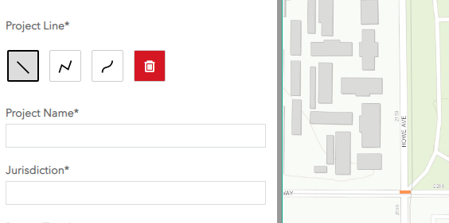

#### Draw A Project with Limited Access Points

Limited-access projects are linear projects whose actual affected area may be better represented by the locations near points where people can access the project instead of the entire project, such as:

* An off-street bike path that can only be accessed via entrances that are far apart from each other.
* A commuter bus that has a few stops at either end but has long freeway-running sections with no stops.
* Other limited-stop transit service with stops spaced far apart (e.g., LRT stations).

If you believe your project, like the examples above, may be more appropriately represented as separate access points rather than as a single line, then draw in lines that only represent the portions of the project at which there are access points. If your project has multiple access points, draw them as described below in “Analyze Multiple Locations as a Single Project”.

#### Analyze Multiple Locations as a Single Project

*Example scenarios*

* Multiple intersection locations that you want to analyze as a single project
* A discontinuous bike path project that comprises multiple, disconnected segments that you want to analyze as one project
* You want to code in just the access points of a limited access project.

*Example multi-location project*

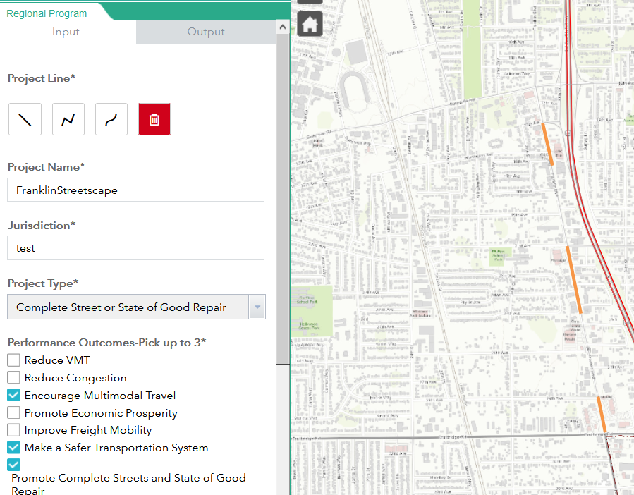

*How to represent in the tool*

1. Draw the first part of the project as normal.
2. After drawing the first project part, click again on the type of line that you want to draw as if you were drawing a new line (do *not* click the delete/trash button).
3. Draw the second part of your project.
4. Repeat steps 2 and 3 for all other portions of your project.
5. After drawing all pieces of your project, fill out the remaining tool fields and run the tool. The resulting report will have maps and numbers representing your multiple project pieces as one project.

#### Drawing Projects to Represent a Parallel Facility

*Example situations*

* Widening or building a new arterial or freeway facility to relieve congestion on a nearby parallel facility
* Building a new off-street bike or pedestrian path to provide people an alternative to biking or walking on what may be a dangerous or uncomfortable street.

*How to represent in the tool*

1. Draw your project at its actual location and run the tool as normal.
2. After running the tool for the actual project location, clear your first project line.
3. Draw a new project line on the parallel facility that your project is intended to improve or complement. Update the project name, ADT, speed limit, and PCI to reflect the parallel facility.
4. Rerun the tool.

*Example of representing parallel facility*

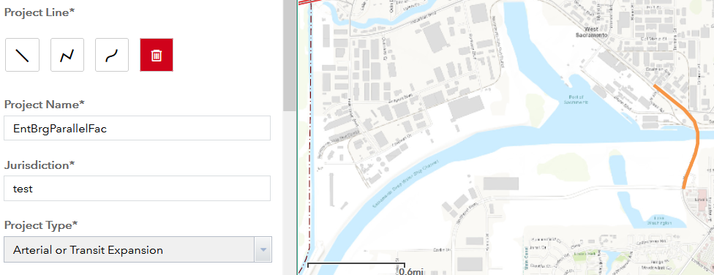

Proposed project (run as separate project)

Affected parallel facility

*Deciding which outputs to use in your application*

To help you and reviewers best evaluate your project’s benefits to a parallel facility, we recommend compiling your report outputs in the following manner in your application:

* Include the title page for BOTH runs in your application
* If you selected any of these performance outcomes, include their pages from BOTH runs in your application:
  + Reduce congestion
  + Improve safety
* For all other performance outcomes, only include their pages for your PROJECT location run.

### Entering Project Data

#### Entering Your Project’s Average Daily Traffic (ADT)

Average Daily Traffic (ADT) is most important for the following three metrics:

* Collision rate per 100 million VMT.
* Estimating how many people are affected by current maintenance conditions at the project location.
* Giving reviewers an idea of how many people are affected by congested conditions at the project location.

Estimating ADT may be challenging. Use the guidelines below to help you estimate ADT for several well-known difficult situations.

* *ADT varies significantly along the project length*
  + If your project segment is long and, per observed traffic counts, has significant variety in its ADT (e.g., ADT at the start is much higher than ADT in the middle but lower than ADT at the end), use your best judgement to provide a single, reasonably representative average ADT for the entire project based on what share of the project’s length has each ADT value.
* *Project covers multiple locations*
  + If your project covers multiple locations that are far apart from each other, such as different intersections or separated segments that are far apart from each other on the same street, we recommend keeping the ADT at the zero default and not incorporating it if your application does *not* cite safety as one of its primary performance outcomes.
  + If, however, you have a multi-location project that has safety as a primary performance outcome, we recommend you run the tool separately for each location of the project to ensure the ADT values are representative of each project location, which in turn will result in more accurate collision rates.
* *If your project is a new road, off-street bike path, or off-street transit project*
  + For new construction projects, you may keep the default ADT value of zero.
* *If your project is supposed to relieve congestion on a parallel facility*
  + If one of your project’s goals is to help divert traffic from an existing facility, follow the directions for parallel facility analysis as described above.

#### Entering Speed Limit

Like ADT, the posted speed limit may vary along your project, especially if you have a long project or your project covers multiple locations. Below are several approaches to reconciling a project that has multiple speed limits within its extent.

* *Leave speed limit as zero if you do not have a complete streets project -* While the speed limit appears on the cover page of the PPA report, it is only used in an evaluative sense to calculate the complete streets index. Therefore if you are not including complete streets or state of good repair in your performance outcomes, then you may leave the speed limit at the default value of zero.
* *Enter a reasonably representative typical speed limit –* if complete streets/state of good repair is one of your project’s outcomes, enter the most reasonable speed limit that captures the “average” speed limit for all locations within your project’s extent, if the speed limits are reasonably close (e.g., within +/-10mph).
* *Run separate project reports* – if the speed limits within your project’s extent vary significantly (more than +/- 10mph), then consider running separate reports to capture the significant variation in your project’s locations. Even if you submit different reports with your application your project will still be evaluated as a single project.
* *Entering current vs. future speed limit -* If your project would change the speed limit, then enter the speed limit that would be in effect if the project were completed.

#### Entering Pavement Condition Index

* *If PCI varies significantly within the project extent* – Similar to handling ADT or speed limits that vary within the project extent, use your best judgement to provide an approximate average PCI for the project. If your project has a few specific locations whose PCI you wish to highlight, please do so in your application narrative.
* *Road maintenance projects without a PCI score –* If your project is a non-surface maintenance project (e.g. bridge structure), leave the PCI as its default zero value and use the narrative section to highlight the other maintenance needs your project will fulfill.
* *Transit projects* - Transit state of good repair projects do not use the PPA, so transit expansion projects using the PPA tool can leave the default zero value in the PCI box. This will not affect any transit outcomes. Transit maintenance projects use the separate Transit Asset Management indicators.

### What Does My Complete Street Index Value Mean?

The complete street index evaluates a street’s potential to benefit from complete streets treatments that allow it to better accommodate a diverse set of road users, and a higher score means the street has more potential to benefit from projects that provide complete street treatments.

Figure 1 through Figure 3 below show some example locations and their corresponding complete street score to give a sense of what a given complete street score may look like on the ground. The supplemental indicator methodology appendix contains more details on the index’s calculation and policy underpinnings.

Figure 1 - West Capitol Ave near Merkley Ave, West Sacramento

Complete street score: 16.4

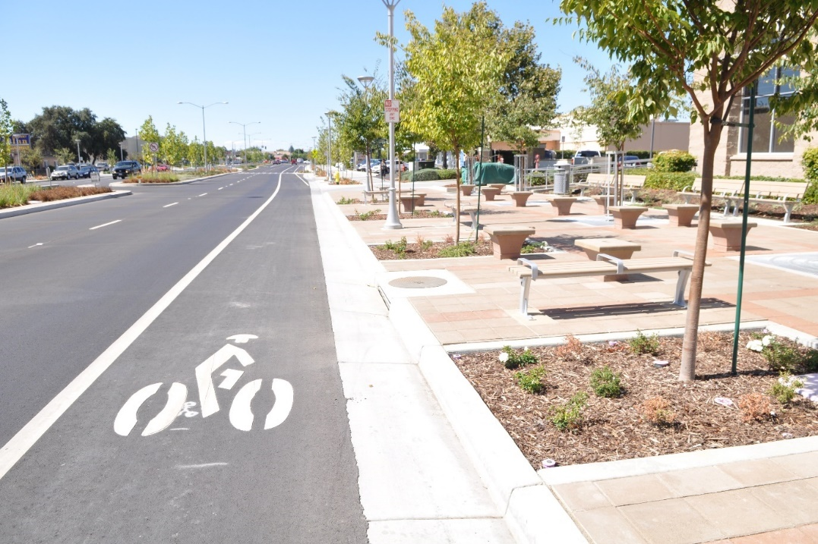

Figure 2 - K Street at 12th Street, Sacramento.

Complete street score: 326.4

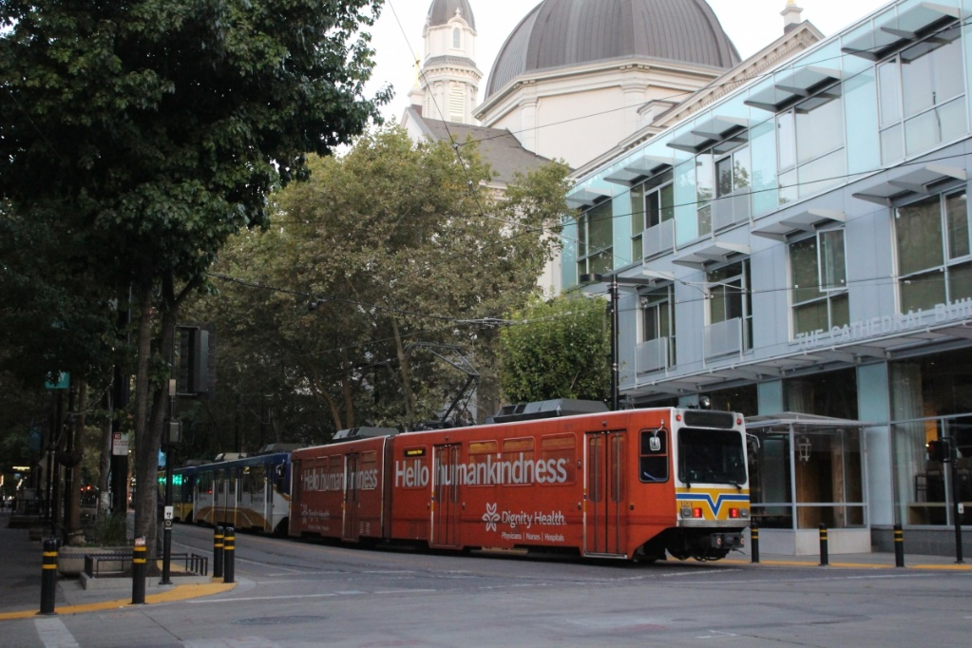

Figure 3 – Main Street at Railroad Avenue, Winters.

Complete street score: 18.1



### Viewing Reports without Excel

The tool output is currently only available in Excel format. If you do not have Excel, we recommend viewing the report through Excel Online, which is available if you have or create an Outlook Online or Office 365 account.

The report can also be viewed through Google’s spreadsheet viewer, and even opened as a Google spreadsheet, but doing the latter may cause some of the report’s charts to display incorrectly.

### Collision Data Seem Wrong

*Total number of collisions seems wrong*

If you think you may not be capturing all collisions on your project segment, check how accurately you drew your line by zooming in on it in the user interface. The tool only counts collisions whose geocoded location is within 75 feet of your project line, so to ensure you are accurately capturing collisions on your project segment, be sure to draw as accurately as possible. Zooming closer in makes it easier to draw accurately.

*Collision rate per 100 Million VMT seems wrong*

The collision rate is based on the total number of collisions found for the project and the average daily traffic (ADT) you entered. If the collision rate seems unreasonably high or low, double check to make sure you entered the most reasonable ADT estimate available.

## Guide to PPA Map Data Layers

| **Layer Name(s)** | **Description** | **Relevant Performance Outcome(s)** | **Project Supports Outcome Better if it…** |
| --- | --- | --- | --- |
| VMT per Capita 2016 | Vehicle-miles traveled per capita | Reduce VMT | is in a low-VMT area |
| STAA Truck Routes | State Transportation Assistance Act designated truck routes | Improve Freight Movement | is on or connects freight routes |
| Bikeways | Existing class 2 bike lanes and class 1 bike paths | Promote Multimodal travel | is on or connects existing bike facilities |
| Environmental Justice (EJ) Areas | Areas with high shares of persons who belong to an ethnic/racial minority, are low income, or have limited English proficiency. | Increase Social Equity | has a higher share of people living near it within an EJ area |
| Collisions | Locations of collisions involving an injury or fatality | Improve Safety | has more collisions per 100 million VMT than community type average |
| Transit Service Density (Stops per Day) | Heat map of frequency of transit vehicle stops occuring in a typical weekday. | Promote Multimodal travel | has more transit stops per acre than community type average |
| Community Types | Based on 2020 MTP community types, but with more categories to enable better comparison of projects in similar built environments. | Various | No effect. Used to compare projects that are within similar built environments. |
| Land Use 2016 (Dwelling Units + Jobs) | Total jobs and dwelling units in 2016 | Reduce VMT | has more dwelling units and jobs near it |
| Job and Dwelling Unit Growth (2016 to 2040) | Increase in combined total of jobs + dwelling units between 2016 and 2040 | Reduce VMT, Reduce CVMT | has more growth in jobs and dwelling units nearby |
| Industrial Jobs 2016 | Total jobs in industrial sectors | Improve Freight Movement | has more industrial jobs near it |
| Land Use Diversity Index, 2016 | SACOG land use diversity index | Reduce VMT | is in an area with a higher index value (max value = 1) |
| Natural Resources, 2016 | Forest and agricultural land | Promote Economic Prosperity; Preserve Natural Resources | is in an agricultural or forestland area that does not urbanize within 2020 MTP horizon |
| Accessibility layers | Count of destinations accessible from each block group within a given travel time for different modes | Economic Prosperity; Reduce VMT; Use Existing Resources | has more jobs, schools, and services accessible through it than its community type average |
| Average Speed (Slowest 4 Hours of the Day) | Average vehicle speed during the most congested 4 hours of a typical weekday in 2018 | Reduce Congestion | is on a road with slower congested vehicle speeds, i.e. responds to an existing congestion need |
| Average Hours/Day in Congested Conditions | Number of hours on a typical weekday during which the actual travel speed is less than 60 percent of the free-flow speed | Reduce Congestion | is on a road that is congested during more hours of the day, i.e., responds to an existing congestion need |
| Reliability Ratio | Measures how consistent travel times are during indicated period. Higher number means segment is less reliable. | Reduce Congestion | is on a road with a higher reliability ratio, i.e., improves a road with poor travel time reliability |

## Supplemental Indicator Methodology

### Conflating NPMRDS Speed Data to Project Lines

As Figure 4 shows, the NPMRDS traffic speed data are provided on segments, called TMCs (traffic message channels) whose end points generally will not line up with a project’s extents. Some shorter projects will be contained entirely within a TMC, but in most cases a project will span multiple TMCs. To reconcile these geometry differences, the PPA tool does the following:

1. Identify which TMCs overlap the project extent, represented by the blue segments in Figure 4

Figure 4 TMC Lines Vs. Sample Project Line

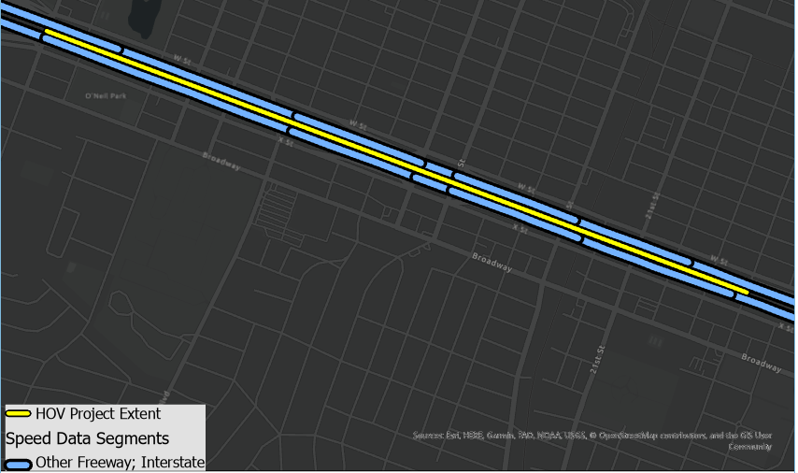

1. For each direction of the project (e.g. east and west), the tool breaks up the project line into pieces whose extents either match up with the TMCs or are contained within a TMC. If a project line is short and within a single TMC, the project line is not split up. This splitting allows a GIS spatial join to occur, in which each TMC’s data gets copied over to the piece of the project line that overlaps it. Figure 5 shows the result of this splitting and spatial join, with the westbound speed being copied over from the blue project line onto the corresponding project piece, and the distance representing the length of that project piece.

Figure 5 Project Line Split to Match TMC Segments with TMC Data Joined to Segments

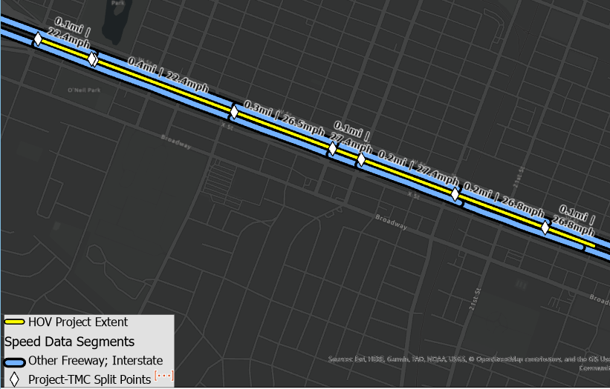

1. After this splitting and spatial joining process, each project piece has the following data:
   1. Free-flow and congested speeds, from the TMC
   2. Level of travel time reliability (LOTTR) also from the TMC
   3. Length of the project piece, in miles

The next step is to aggregate these values into a single number that represents, for example, the average representative speed for the entire project extent, or its overall level of travel time reliability.

The tool calculates the project’s average speeds (both the free-flow and congested speeds) through the following steps, which are summarized in the equation below

1. For each piece, get the inverse of its speed, or “hours per mile”, and multiply this hours-per-mile rate by the piece’s distance in miles. This returns the travel time, in hours, to traverse the piece.
2. Sum the results from step 1 for all pieces, which will give you the total travel time, in hours, to traverse the entire project segment.
3. Divide the total project length, in miles, by the total travel time, in hours, which returns the average project speed, in miles per hour.

Where:

* SP = Average speed, in miles per hour, for entire project extent
* Si = Speed, in miles per hour, of project piece i
* Di = Distance, in miles, of project piece i

To calculate the average LOTTR, the tool takes a simpler distance-weighted average:

Where:

* RP = Distance-weighted travel time reliability for entire project extent
* Ri = travel time reliability on project piece i
* Di = Distance, in miles, of project piece i

### Calculating Project-Level Accessibility

Accessibility data come from Sugar Access and are provided in census block geographies, which you can view in the map layers of the tool interface. Given that projects are lines, and most projects span multiple census blocks, the tool must get an “average” level of accessibility for the project line.

To calculate the average accessibility, the tool does the following, for each accessibility metric (e.g. number of schools accessible by walking, number of jobs accessible by biking, etc.):

1. Select all census blocks within 300 feet of the project line, or all census blocks that are within roughly half a physical, street block of the project line.
2. Get the average accessibility to destinations using one of the following methods:
   1. *If* ***no one*** *lives in lives in the census blocks within 300 feet of the project line*, the average accessibility for the project is the simple, unweighted average of the accessibility for the selected census blocks.
   2. *If* ***one or more******households*** *lives in any of the census blocks within 300 feet of the project line,* theproject’s accessibility score is the population-weighted average accessibility of the census blocks, calculated using the formula below:

Where:

* Adm = Population-weighted accessibility to destination type “d” using mode “m”
* Aidm = Accessibility to destination type “d” from census block “i” using mode “m”
* Pi = Population of census block “i”

The population-weighted accessibility gives a sense of how accessible something is for an average person living in a census block within 300 feet of the project line, e.g., if a PPA report says accessibility to schools in a 30-minute bicycle ride is 7.5, it means the average person living near the project line can access 7.5 schools within a 30-minute bicycle ride.

#### Accessibility for People Environmental Justice Areas

Within census blocks near the project line, designated Environmental Justice (EJ) areas may be concentrated within one part of the project, and therefore the average accessibility for the entire project may be different than the accessibility for the parts of the project that are within EJ areas. To account for this, the tool has a separate indicator, under the Social Equity performance outcome, for EJ-population weighted accessibility.

The formula to calculate EJ-population-weighted accessibility is essentially the same as the formula above used for all-project accessibility, except instead of population Pi representing the whole population, it only includes populations within EJ areas.

### Complete Streets Index Methodology

The complete streets index (CSI) aims to evaluate a street’s potential for being a “complete street” that provides a comfortable environment and effective means of mobility for users of all modes. The CSI formula, provided below, is based on the following assumptions:

The following factors *increase* the CSI:

* A higher density of school students, since students are more likely to walk to school, younger children are more vulnerable to safety risks posed by auto-oriented streets, and schools tend to generate large amounts of foot traffic on school days.
* More transit service, which results in more pedestrians since most transit trips include a walking trip to access the stop.
* Higher density of jobs and/or housing, which means a higher number of origins and destinations nearby and thus a higher potential for investments in bike and pedestrian infrastructure to shift short driving trips to being made by biking or walking
* Slower posted speed limits, since slower speeds reduce the incidence of fatal collisions and create a more comfortable biking and walking environment.

In contrast, once a project’s posted speed limit rises above 40mph, higher speeds will *decrease* a project’s CSI. The policy assumption behind this is that high-speed roads are inherently less compatible with having non-auto modes nearby or sharing the same space due to a less comfortable walking/biking environment and higher risk of fatal collisions at high speeds.

( )*P)

Where:

* CSI = Complete Street Index
* DS = students per acre (at school location, not home location)
* DT = transit vehicle stops per acre per day
* DJ = jobs per acre
* DD = dwelling units per acre
* SP = Posted speed limit
* ST = Threshold speed at which the speed penalty factor begins affecting the index value. For PPA2 this is 40mph.
* P = Speed penalty factor, set to 0.04 for PPA2

### SACOG Land Use Diversity Index

The land use diversity index measures an area’s ratio of households compared to neighborhood amenities including K-12 enrollment, park acreage, and employment in the retail, service and food sectors, which are presented in the “land use factor” column of Table 1. A score of 1 indicates an ‘ideal’ ratio of households to amenities that people use on a daily basis like shopping, restaurants, schools, etc. Areas with a mix of land uses increase the likelihood that vehicle trips are shorter per capita and can also be served by active transportation modes. The land use diversity uses a buffer of 1 mile, instead of the shorter 0.5 mile buffer used in other buffer metrics.

The “ideal” ratio of households to amenities is based on the ratio of households to amenities for the entire SACOG region, shown in the “regional ratio” column of Table 1. The assumption is that if the ratio of households to amenities within a one-mile buffer of a project matched that of the region as a whole, then those households would live within an easily walkable or bikeable distance to those amenities and therefore drive less to access them, or at least drive a shorter distance. Conversely, it also means that those amenities’ users are more likely to access the amenities by either walking, biking, or driving a shorter distance.

The “weight” column captures which, in professional judgement, are the land use factors that have the most potential to reduce trip lengths if people live near them. For example, people will tend to go to the schools and retail stores closest to their homes, so if they have schools and retail within an easily bikeable or walkable distance from their homes, they are likely to patronize those facilities and thus be more likely to walk, bike, or at least have a shorter driving distance. Conversely, jobs are given a relatively low weight because people have far less choice over where they work than where they shop and are not as likely to choose a job just because it’s the closest to their homes.

Table 1 – Land Use Diversity Index input factors

|  |  |  |
| --- | --- | --- |
| **Land Use Factor** | **Regional ratio (hh/factor)** | **Weight** |
| K-12 School Enrollment | 0.39 | 0.2 |
| Total Jobs | 1.09 | 0.05 |
| Retail Jobs | 0.15 | 0.4 |
| Service Jobs | 0.13 | 0.1 |
| Food/Restaurant Jobs | 0.10 | 0.2 |
| Acres of Parks | 0.27 | 0.05 |

The steps to calculate the land use diversity index for a project are the following:

1. From parcel-level data within one mile of the project line, get the total number of households and total numbers for each of the land use factors listed in Table 1
2. For each land use factor, calculate the ratio of households to that factor (e.g. households per job, households per k-12 student, etc.)
3. For each of these ratios:
   1. If the ratio value is less than the regional factor, divide the ratio value by the regional factor. If the ratio value is greater than or equal to the regional factor value, divide the regional factor value by the ratio.
   2. Example: if regionally there are 0.39 households per student but the project has 0.24 households per student, divide 0.24/0.39; if the project had 0.56 households per student, divide 0.39/0.56
   3. The resulting number for each factor is called the “balance ratio”, i.e., how well the project’s ratio compares to the ideal, regional ratio.
4. Multiply each of the balance ratios by the weights specified in Table 1. The result from each multiplication is the “weighted balance ratio”.
5. Sum up the weighted balance ratios. This is the land use diversity index value.

An important aspect of the land use diversity index is that it works both ways, i.e., a project that has mostly homes around it and few nearby amenities will score as low as a project that has many jobs and/or services around it but few households. In both of these scenarios, the land use mix implies that there are not many households living near destinations the people use on a regular basis, and therefore the people or facilities occupying the land will generate more and longer driving trips due to greater travel distances.